Lessons from 2018: CA-10 Case Study
Founded in 2003 as the community organizing arm of the AFL-CIO, Working America mobilizes working people who don’t have the benefit of a union at work to fight for good jobs and a fair economy. We have held over 13 million face-to-face conversations across 43 states and organized 3.3 million voters to become Working America members. We have worked in more than 500 elections, winning more than 6 out of 10 campaigns. In the course of that work, we have built a library of hundreds of randomized clinical measurements of our electoral program. This experience is the foundation of our continuing efforts to run one of the most measurably effective programs in progressive politics.
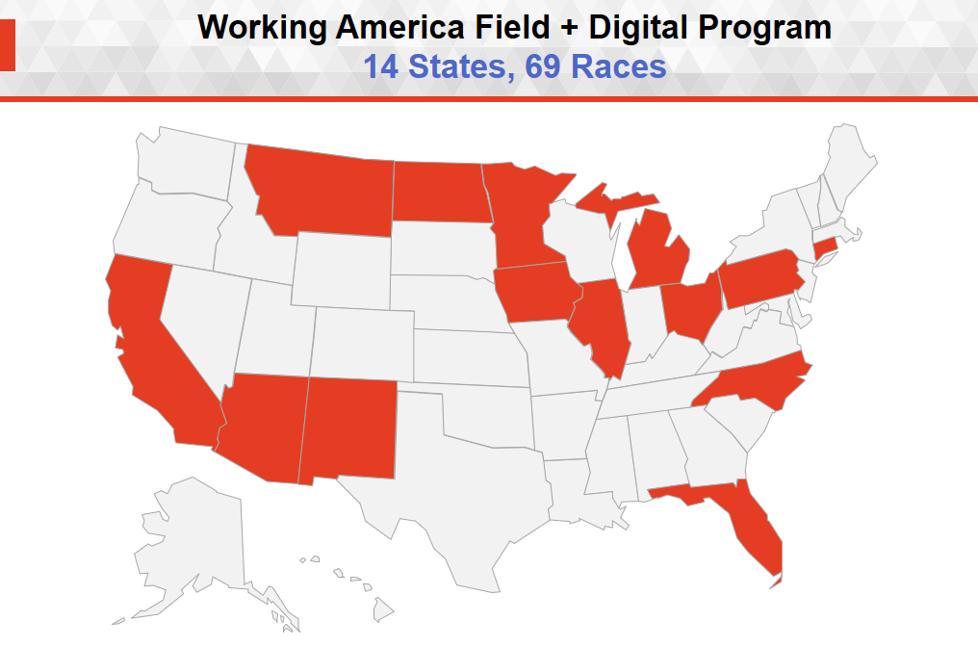
2018 Elections
In 2018, we applied our accumulated experience to 69 competitive elections, adding thousands of votes for our endorsed candidates. Our program helped put our candidates over the top in 50 races, yielding a 72 percent win rate, including:
- 5 of 7 gubernatorial contests: IA, IL, MI, MN, NM, PA, OH
- 4 of 5 U.S. Senate contests: AZ, MN, MT, ND, OH
- 4 of 5 U.S. House contests: CA-10, IA-01, MN-02, PA-17, OH-12
Our Approach
We believe in sustained, year-round organizing that builds membership at the same time we deepen our community roots. Our fully unionized, professional team of canvass organizers receives an hour of training each day and is effective at building relationships with voters by starting the conversation with, “What is most important to you?” The face-to-face relationship established at the door is followed with multi-channel intensive digital engagement. Each aspect of the program — field and digital — is assessed and refined using randomized clinical experiments to measure the effects.

CA-10: A Case Study
Our work in California’s 10th Congressional District is an example of our organizing strategy in practice.
Initial Assessment: Much was made of GOP Rep. Jeff Denham’s (CA-10) 2016 victory in a district that was also won by Democrats Clinton and Obama. One sign of Denham’s popularity with voters was that he consistently ran +6pp ahead of the Republican presidential nominees and +2.3pp ahead of the Democrats. Initial surveys of voters showed that while he was broadly popular among and familiar to voters, they had little awareness of his record. He also showed particularly strong support among Democrat-leaning Latinx voters.
Issue Organizing: Armed with this initial assessment, we launched our issue-based campaign in summer 2017 in Modesto to hold Denham accountable for his efforts to repeal the Affordable Care Act and deprive his constituents of access to affordable health care — a particularly resonant issue in the Central Valley.
Our fully bilingual canvass organizing team recruited 36,282 Working America members, generating 25,838 petition signatures in 12 months calling on Denham to protect the ACA.
This non-partisan issue education campaign laid the groundwork to soften Denham support, especially among Latinx and even some Republican voters in the district.
Randomized Testing for Targeting and Messaging: Following the issue organizing campaign, we turned our attention to conducting a large-scale field survey of 588 voters. This project, part of our Front Porch Focus Group series of reports, explored voter sentiments on a range of issues including immigration, education, health care and taxes, as well as candidates.
These unique, long-form surveys combine the scale of public opinion polls with the depth and texture of focus groups. Our report revealed a) Democrat Josh Harder was still relatively unknown and Denham was well-liked, b) voters held a deeply ingrained identity as Central Valley residents who rejected coastal city politics more in concept than substance, and c) most voters were unfamiliar with Denham’s record and how it diverged from the economic interests of this almost entirely working-class district.
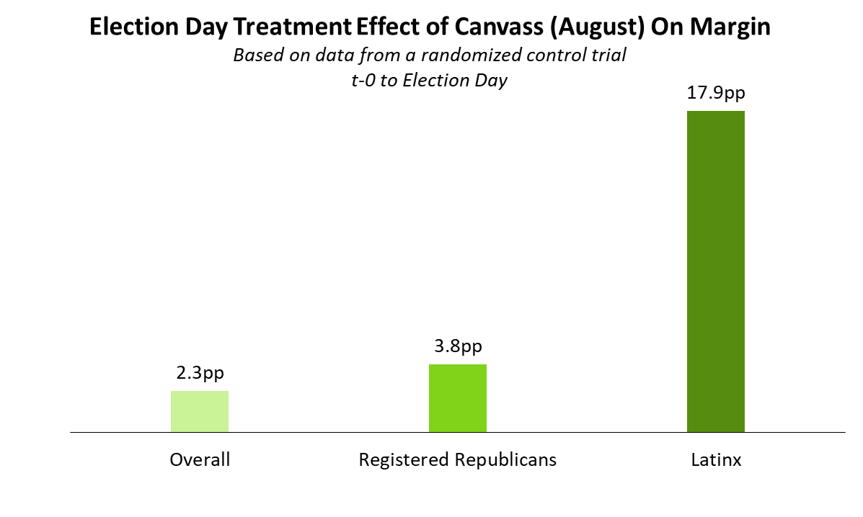
In addition to generating the Front Porch Focus Group report, we conducted a clinical test of the canvass and our digital programs, randomly assigning some voters to receive persuasion messages and others to receive a placebo.
The results found surprising groups of persuadable voters — including registered Republicans who defected from the Denham camp upon learning about his record in Congress.
These clinical tests uncovered critical pockets of persuadable voters to target during the voter contact program. They also validated separate Working America persuasion models built by combining a dozen prior clinical experiments.
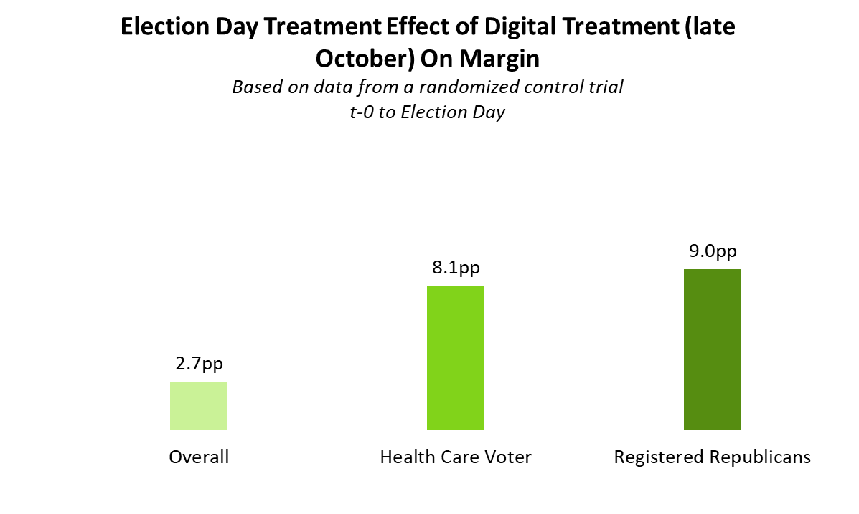
Electoral Engagement: Armed with fresh targeting data and message framing generated from our work at the doors, Working America canvassers visited 55,000 homes and held nearly 15,000 conversations with voters in CA-10 from Labor Day to Election Day. We contacted an additional 19,228 Working America members through a combination of digital ads, texts and email messages with persuasive content about Harder. The initial clinical analysis shows that the Working America digital communication program in the Central Valley gained votes at a cost of $18 apiece.
Integrated Volunteers: With its proximity to the Bay Area, Modesto presented an opportunity to develop and engage hundreds of volunteers from Resistance groups, most of whom were new to door-to-door canvass organizing. This volunteer organizing took place almost every weekend, augmenting the work of the professional canvass.
The Next Phase: Having succeeded in the general election, we are now planning to mobilize Working America members in CA-10 to advance a progressive issue agenda. Unsurprisingly, post-election interviews of members indicate that access to affordable health care, rising housing costs and reliable transportation to employment remain top concerns.
We are in the process of raising a 12-month, $200,000 budget to support a team of organizers and continued digital education with members.
November 3, 2020
Looking ahead to 2020, the GOP will no doubt try to reclaim CA-10 and dozens of other Congressional seats while also working to re-elect Donald Trump. Yet, we see a clear and compelling path to holding onto our gains and ensuring Trump is a one-term president.
Using the combined insights of dozens of clinical experiments validated in Election Day results, we are able to reliably predict which voters are persuadable ahead of the next election. We also see consistent evidence that voters are far more responsive to electoral turnout and persuasion contacts when they have been engaged on an issue beforehand. Working America and our progressive allies can substantially improve our prospects for success by starting the conversation with these voters on the doorsteps to help them connect the dots.
To win in 2020, we must reach millions of persuadable voters at their doorsteps to find the connection between the real concerns of voters and the choices they’re making at the polls.

